**Lab 5: Microphone Circuit**

**Keegan** **Smith**

**Bench** 02

**Electronics** II Lab

**EECE.3120 803**

**Date submitte**d 09/21/2022

**Due date** 09/21/2022

1. **SUMMARY**

**N/A**

1. **EQUIPMENT**

**Table 1. Equipment**

|  |  |  |
| --- | --- | --- |
| **Equipment Type** | **Details** | |
| * Oscilloscope | *Make:* | Tektronix |
| *Model:* | MDO3014 |
| *Serial Number:* | CO44915 |
| * Digital Multimeter | *Make:* | Keithley |
| *Model:* | 2110 5½ |
| *Serial Number:* | 8007691 |
| * DC Power Supply | *Make:* | Keithley |
| *Model:* | 2231A-30-3 |
| *Serial Number:* | Unable to acquire |
| * Function Generator | *Make:* | Tektronix |
| *Model:* | AFG1022 |
| *Serial Number:* | 1731386 |
| * Analog Discovery | *Make:* | Digilent |
| *Model:* | Analog Discovery 2 |
| *Serial Number:* | 210231B0DF82 |
| * Handheld Digital Multimeter | *Make:* | Tenma |
| *Model:* | 72-9385 |
| *Serial Number:* | H200487467 |
| * Breadboard * Bench “Shoebox” with connector cables, adapters, clips etc. | N/A | |

**Table 2. Components**

|  |  |  |
| --- | --- | --- |
| **Component Type** | **Quantity** | **Details** |
|  | 1 | Electret Condenser Microphone Cartridge MIC |
| IC | 1 | Dual Wide-band JFET Op-amp U1 |
| Resistor | 2 | 2.2k |
| Resistor | 2 | 10k |
| Resistor | 1 | 33k |
| Trimpot R6 | 1 | 10k |
| Capacitor | 1 | 1 μF |
| Capacitor | 1 | 10 μF |
| Capacitor | 2 | 100 μF |
| Capacitor | 1 | 0.001 μF |
| Capacitor | 2 | 0.1 μF |

1. **INTRODUCTION**

**N/A**

1. **CIRCUIT DESCRIPTION**

Figure 1. Microphone Gain Stage

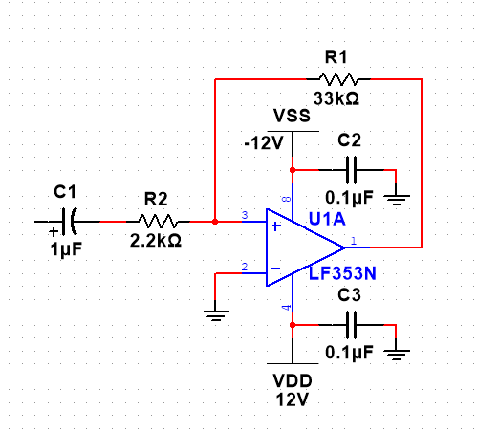

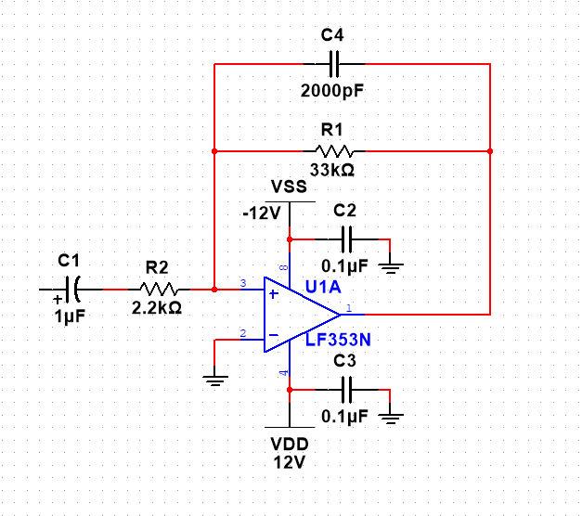Figure 2. Microphone Gain Stage with 2000pF Capacitor for High Frequency Response

Figure 3. Microphone Bias Network

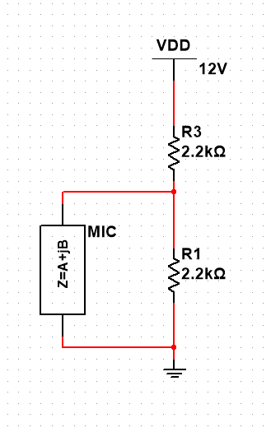

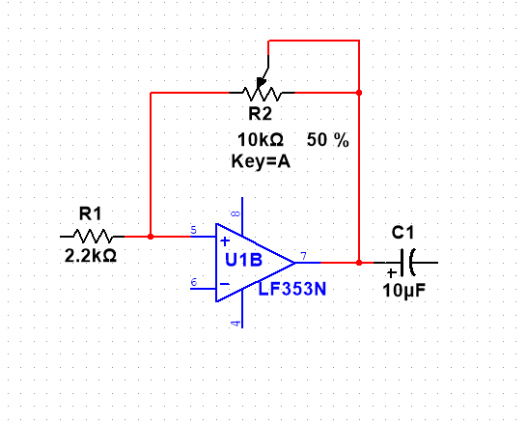Figure 4. Inverting Stage

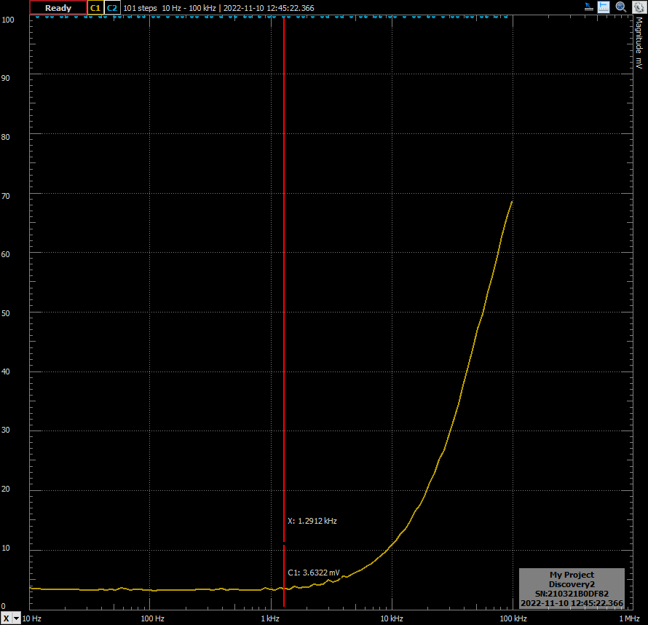Figure 5. Frequency Sweep with Analog Discovery for the Low Frequency Cutoff

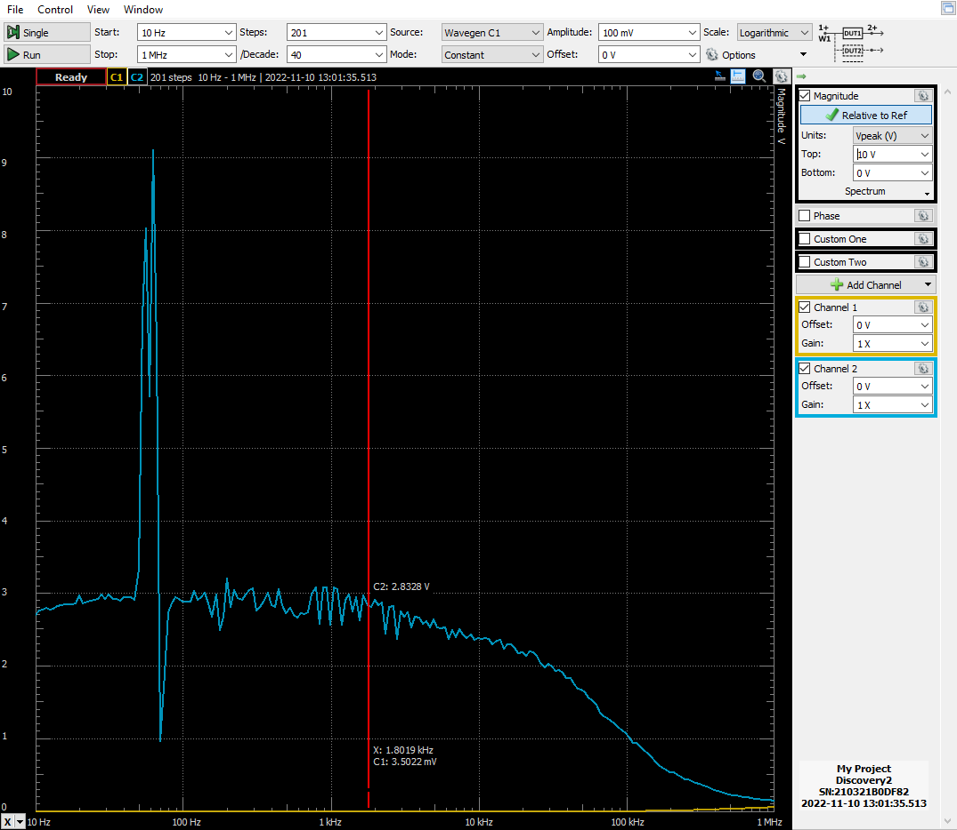Figure 6. Frequency Sweep with Analog Discovery for the High Frequency Cutoff

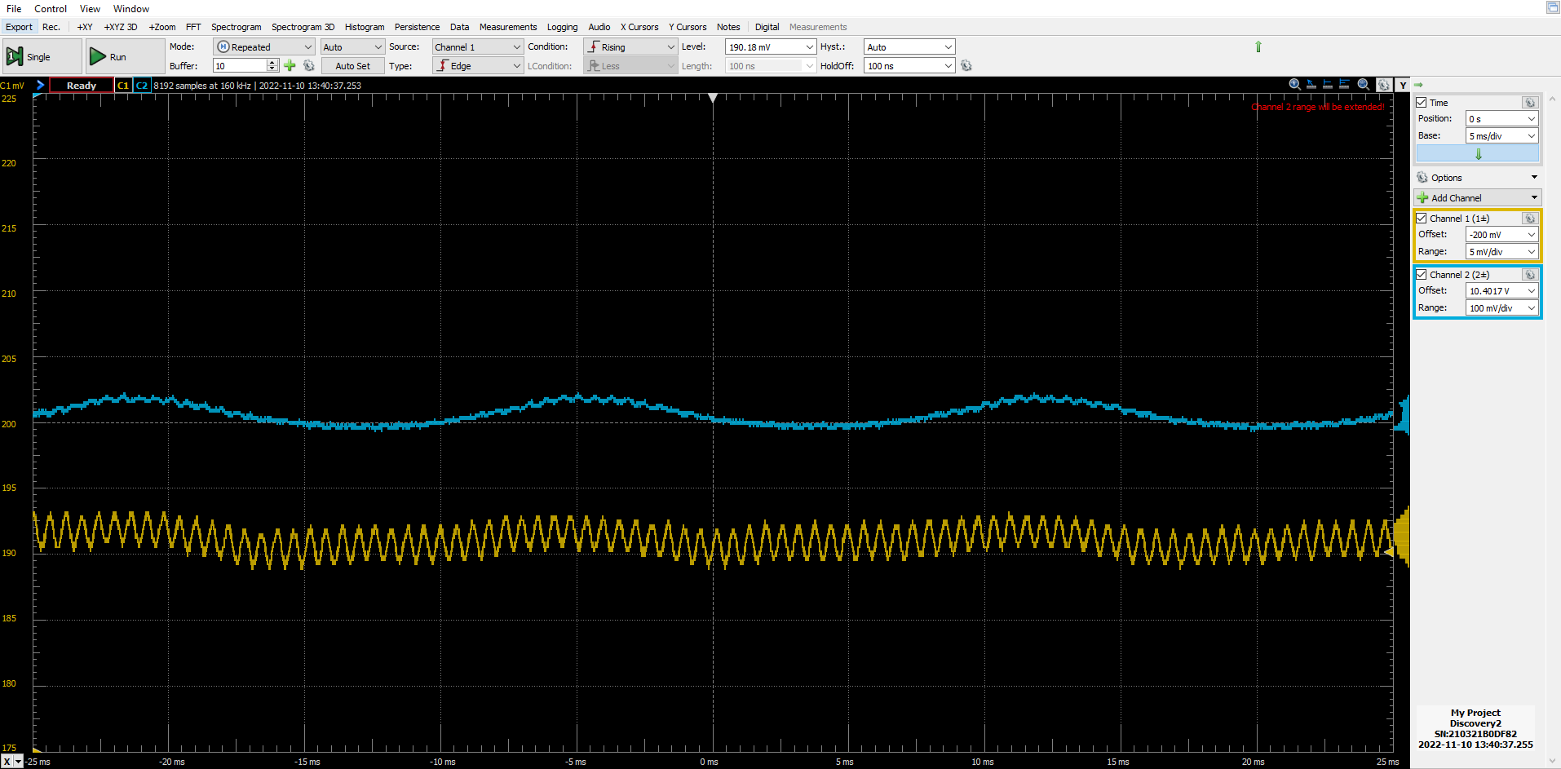Figure 7. Microphone (channel 1) and Figure 1, Microphone Gain-Stage (channel 2) outputs

Note: This measurement was taken while whistling approximately 6 inches away from the microphone

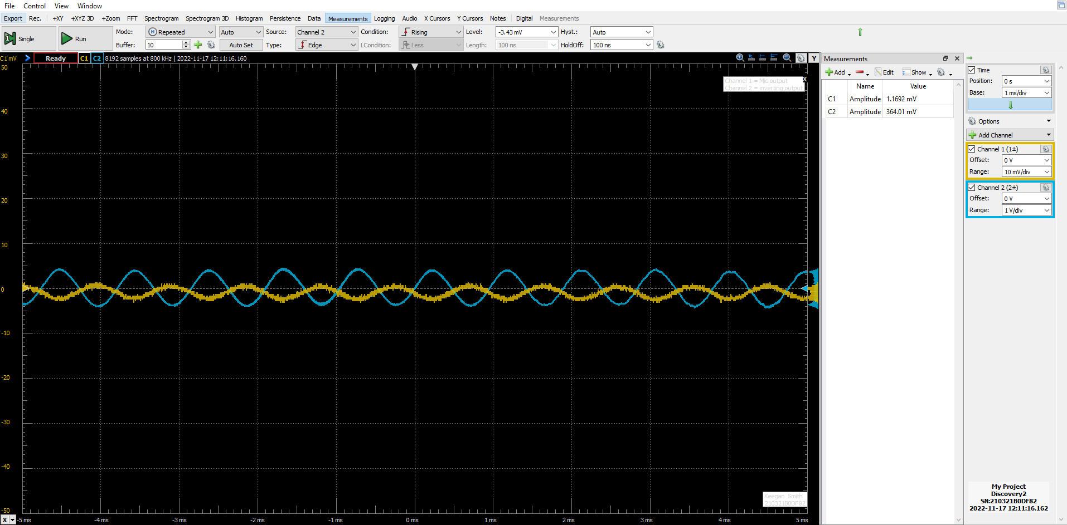Figure 8. Microphone (channel 1) and Amplifier Circuit outputs

Note: This measurement was taken while whistling approximately 6 inches away from the microphone

1. **MEASUREMENTS**

Table 1. Microphone Gain Stage Frequency Sweep

|  |  |  |
| --- | --- | --- |
| **Value** | **Measured** | **Calculated** |
| Low Frequency 3dB cut off | 1.284k Hz | 72.343 Hz |
| Mid-Band Gain | 0.00127 V/V | -15 V/V |
| High Frequency 3dB cut off | 1.8019k Hz | 2000 Hz |
| Mid-Band Gain | 1.238 V/V | -15 V/V |

Table 2. Microphone Bias Voltage

|  |  |
| --- | --- |
| **Value** | **Measured** |
| VBias | 4.8v |

Table 3. Multistage Microphone/audio Amplifier Output Amplitude

|  |  |
| --- | --- |
| **Value** | **Measured** |
| Output Amplitude  With C2 | 63.7 mV |
| Output amplitude with C2 removed | ~100 mV |

1. **DISCUSSION**

The first part of the procedure is to perform calculations to find the high and low cutoff frequencies. This is done using the following two formulas:

$τ=RC$ equation 1.

$f_{H}= \frac{1}{2π(τ_{1}+ τ_{2}+τ_{…})}$ equation 2.

$f_{L}= \frac{1}{2π}[\frac{1}{τ_{1}}+ \frac{1}{τ_{2}}+ \frac{1}{τ_{…}}]$ equation 3.

With these formulas I found that the high frequency cutoff to be equal to the low frequency cutoff because there is only a single capacitor on the input of the microphone gain circuit seen in figure 1. However, looking at the results of the frequency sweeps in figures 5, figure 6 and table 1, this is not correct. The fault is known and lies within the calculations and will be discussed further in the conclusion.

The next part of the procedure is to construct the Microphone’s bias network. This circuit is a voltage divider cutting the 12-volt source down to 6 volts. This circuit uses the principle that current does not change in a series circuit and that voltage does not change in a parallel circuit. The concept allows us to set the voltage across the microphone because it is in parallel with the resistor with the divided voltage. The equation for this is as follows:

$V_{N}= V_{S}(\frac{R_{1}}{R_{3}+R_{1}})$ equation 4.

VN being the network voltage (divided voltage), VS the supply voltage. Resistances’ locations can be referenced in figure 3. However, because the resistance values are equal, VN will be equal to one half VS.

Section three is the testing of the microphone. The output from the microphone is connected to the input of the gain-stage amplifier in figure 1. To perform this, you whistle around 6 inches into the microphone. Though, during initial testing and set up of the oscilloscope, I would snap my fingers. Looking at figure 7, we can see the results of whistling into the device.

Section four is similar to section three of the procedure. Here we connect the output form the gain stage into an inverting amplifier. This part allows for volume control as well as to create a type of buffer between the microphone and the speaker circuit in the next part of the experiment.

The fifth and final experiment is to connect the output of the inverting amplifier to the input of the amplifier circuit constructed in lab 4. The circuit network take the inputted analog signal, you whistling, converts it to a digital signal, processes it by sending it through multiple stages of amplifiers for volume, and signal processing, and converts it back into an analog signal for the speaker. My results from this can be seen in figure 8. In this screen capture from the Analog Discoveries oscilloscope function, we see the microphone input, channel 1, has an amplitude of around 1.2mV and the output to the speaker, channel 2, has an amplitude of around 364mV. We can also see that the signal is not very clean looking. This could be fixed by moving the microphone and speaker system further away from each other to reduce noise, or we could add a differential amplifier to the speaker system. These amplifiers remove noise from a signal by removing any differences between the positive and negative inputs of the amplifier.

1. **CONCLUSION**

This laboratory experiment went rather smoothly for me. I did not have many issues with the circuits and the ones I did have, I was able to solve mostly on my own. As mentioned in the first paragraph of the discussion, my calculations for the high and low cutoff frequencies were wrong. This was due to me seeing the single capacitor on the input using only the 1µF capacitor and the 2.2kΩ resistor with the two equations to find the frequencies. The problem with this is that the equations equal each other when there is one time constant. This was a section of the lab I meant to come back to and recalculate the frequencies, but never did. To find these values the correct way, we would have to perform a circuit analysis including the internal equivalences of the op-amp. However, I still see the frequencies matching due to the single time constant.

1. **QUESTIONS**

**N/A**

1. **REFERENCES**
2. York, B. (n.d.). Audio Amplifier Circuit. Retrieved from <http://www.ece.ucsb.edu/Faculty/rodwell/Classes/ece2c/labs/Lab3_2C_2007.pdf>
3. Recitation Textbook
4. “Lab 5: Microphone Circuit.” *Lab5 Lab Procedure*, University of Massachusetts Lowell, 2018.